**AWK SCRIPT**

**4.A.) EMPLOYEE AVERAGE PAY**

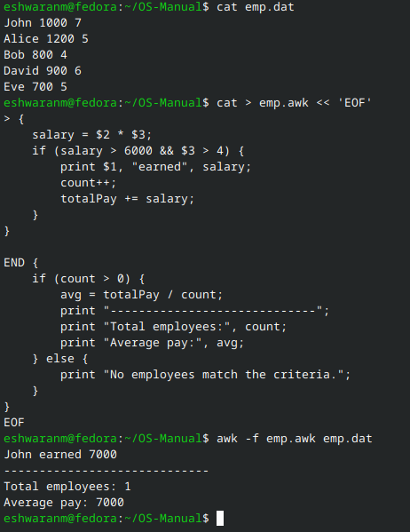

**4.B.) RESULTS OF EXAMINATION**

